Learning Journal Unit 2

Godfrey Ouma
University of the People
MATH 1280: Introduction to Statistics
Esther Pearson
21 September 22, 2023

Learning Journal Unit 2
We are given a table for the city of Detroit, Michigan USA for the period of 1961 to 1973 with the following information: a column with the number of full-time police per 100,000 citizens and a column with the number of homicides per 100,000 citizens.
Year | Police | Homicides
1961 | 260.35 | 8.6
1962 | 269.8 | 8.9
1963 | 272.04 | 8.52
1964 | 272.96 | 8.89
1965 | 272.51 | 13.07
1966 | 261.34 | 14.57
1967 | 268.89 | 21.36
1968 | 295.99 | 28.03
1969 | 319.87 | 31.49
1970 | 341.43 | 37.39
1971 | 356.59 | 46.26
1972 | 376.69 | 47.24
1973 | 390.19 | 52.33
1. On the same x-axis representing the year, construct the time series of the number of police and the number of homicides on the same graph.
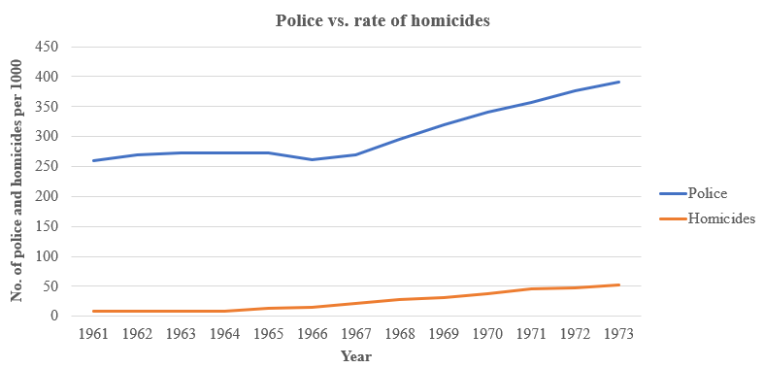
2. Which variable increased the fastest (police or homicides)? Why?
The data provided can be measured using the ratio scale since it takes care of the ratio problem to give more information (Illowsky et al., 2022) such as the variable that increased the fastest. For that reason, it is possible to calculate the annual growth rates for both police and homicides to determine which variable increased the fastest using the formula below:
$Annual Growth Rate (\%) = \frac{Value in the last year-Value in the initial year}{Number of years}$
$Police Annual Growth Rate \left(\%\right)= \frac{390.19-260.35}{12}≈10.85 police per year$
$Homicides Annual Growth Rate (\%) = \frac{52.33-8.6}{12}≈ 3.11 homicides per year$
It is evident from the calculations above that the variable that increased the fastest is homicides, with an annual growth rate of approximately 3.11 homicides per year. This significant increase in homicides is much higher than the increase in the number of police officers, which had an annual growth rate of approximately 10.85 police per year. Albeit the police are an important part of maintaining the rule of law, Bal (2023) links the increasing homicide rate in Detroit for the years 1961-1973 to high unemployment rate, increased number of licensed guns, and poorly paying jobs.
3. Did the increase in police officers have an impact on the murder rate? Why?
Based on the annual growth rates for both police and the homicide cases, it seems the increase in police officers does not appear to have had a significant impact on the murder rate in Detroit. Despite the increase in the number of police officers over the years, the homicide rate increased substantially, as indicated by the high annual growth rate of homicides. Since socioeconomic factors such as high unemployment rate, increased number of licensed guns, and poorly paying jobs are beyond police control, it helps to explain why increase in police officers have insignificant impact on the murder rate.

References
Bal, D. (2023). Homicide rates in Detroit. https://rstudio-pubs-static.s3.amazonaws.com/68635_700e245ce3bc4c3ca2ce30c040c800d9.html
Illowsky, B., Dean, S., Birmajer, D., Blount, B., Boyd, S., Einsohn, M., Helmreich, J., Kenyon, L., Lee, S., & Taub, J. (2022). Introductory statistics. Openstax. https://openstax.org/details/books/introductory-statistics

